Create Budget Request Event (Facilities)
Overview
Enter a Budget Amendment into the Workday workflow for approval on requests for funding, and requests for additional funding on accounts already established.
Considerations
None
Initiation
Security Roles: unknown
- Enter Create Request into the search bar and select the blue link titled Create Request. Selecting a link is the first ‘task’ in the Workday event.
(Shortcut, type: Cre Req or any other partial word)
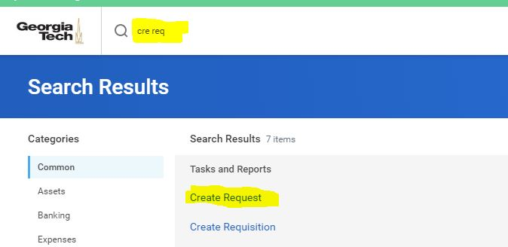

- Enter the following information:
  - Request Type: With this field you are selecting the routing queue. Budget requests should be routed to either the Associate Director of Design or the Associate Director of Construction. Click All, then select the AD that you report up through: Construction Project Budget Amendment Request or Design Project Budget Amendment Request
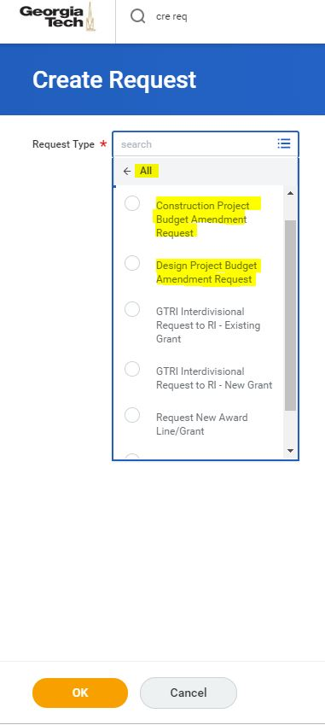
- Select OK

- Enter the following information:
  - Describe the Reason – Provide a general description of the budget amendment
  - Facilities Project Number – e.g. 1234-1029
  - Project Title: Name of the project
  - Amendment Number: Use zero if this is the first budget request on a project
  - Amount Requested: Enter the amount of funding requested in the budget request being routed.
  - Amended Total Project Budget: This is the total amount of funding requested to date, including the request being routed. Note that if this is your first funding request on a project, the amount requested and the amended total project budget fields will be the same amount.
  - Building: Enter the building name and number.
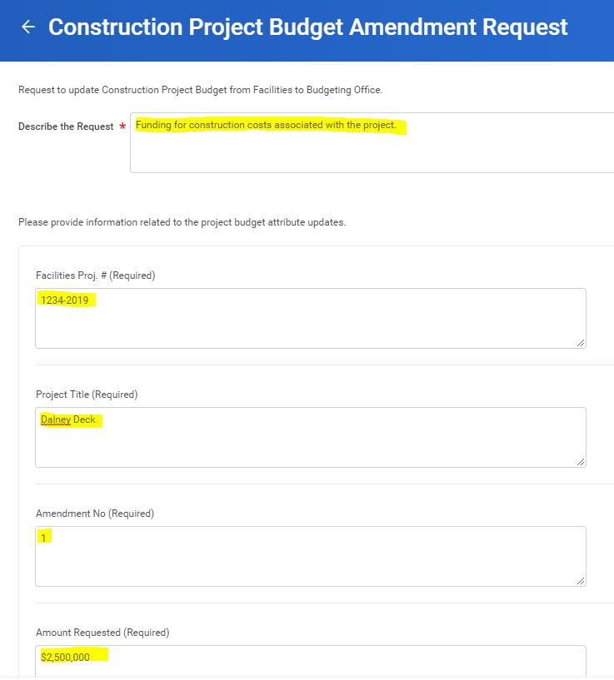

- Enter the Worktags and Amounts :
  - First Time Budget Request – Put a TBD for the Worktag (funding account information) and enter the amount requested in this amendment in Amount 1.

  - Amendment to an Established Budget - Enter the previously provided Worktag (funding account information) and enter the amount requested in this amendment in Amount 1.
- Attach the Capital Project Budget Request Form
  - Budget forms are available on the budget office website:
http://www.budgets.gatech.edu/mForms/Forms

  - An example of how to fill out the budget form is available on the Facilities Forms Website here: https://facilities.gatech.edu/sites/default/files/capitalprojectbudgetformexample_100111.pdf

  - Name the Capital Project Budget Form as follows: Facilities ProjectNumber_ProjectName_Amendment Number
1234-2019_DalneyDeck_Amend01
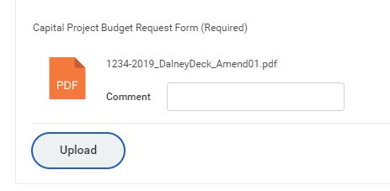

- Use the Cloud Notes for any comments to the reviewer/s

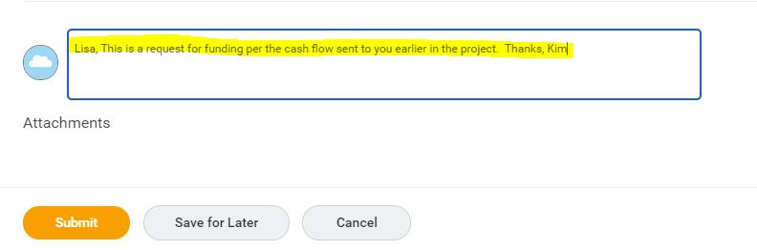

- Select:
  - Submit: to submit the budget amendment for review and approval.
  - Save for Later: to return and finish the budget amendment later
  - Cancel: to delete your work

FACILITIES APPROVAL STEP for Budget Amendments

- Budget Amendments that are ready for review will be in your Workday inbox.

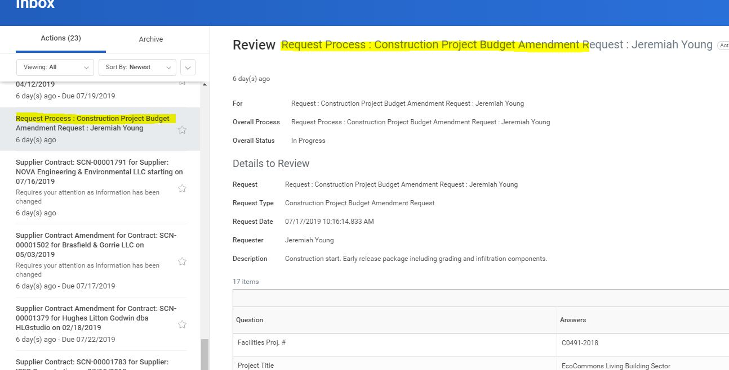

- Click on the Budget Amendment that you want to review first.
- Review Action Options:
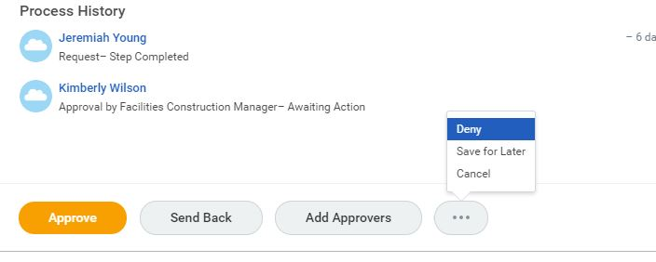
  - Approve: Select the Approve button at the bottom of the screen to approve the budget amendment.
  - Send Back: Select the Send Back button at the bottom of the screen. Click on the name of the person who initiated the budget request, or another person in the review workflow to send the budget amendment back. Add notes in the comment box associated with the Send Back button to explain why the contract has been returned.
  - Add Approvers: Select the Add Approvers if additional review outside of the workflow is required ad hoc. Type the first name and first few letters of the person’s last name to search for the person to add. Select the person and add a note regarding why they may need to review the contract.
  - Cancel: This will stop the amendment (confirm)
  - Deny: This will stop the amendment and return it to the originator. (confirm)
  - Save for Later: This will allow you to leave the review of the budget amendment and come back to your inbox later.

Status Report for Budget Amendments: All Requests

To look at a report of all active budget amendments, and to check on the status of your budget amendment, utilize the report: All Requests
      - Go to the magnifying glass and type: All Requests. Click on the link to open the query.
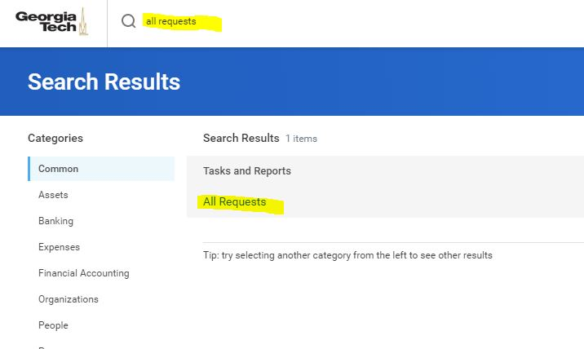

      - Go to Request Type and select both Design Project Budget Amendment Request and Construction Project Budget Amendment Request
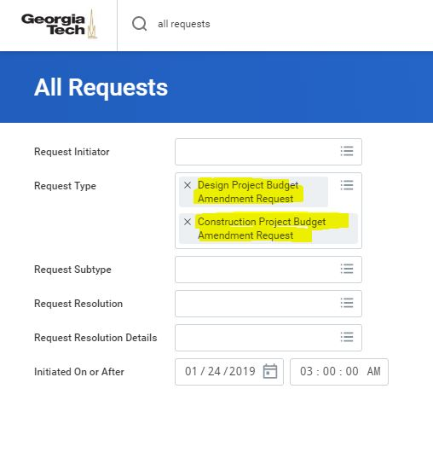
      - Click OK (orange button at bottom of screen). Report will run.
      - Note that you can click on any column header and search or sort to filter the report.

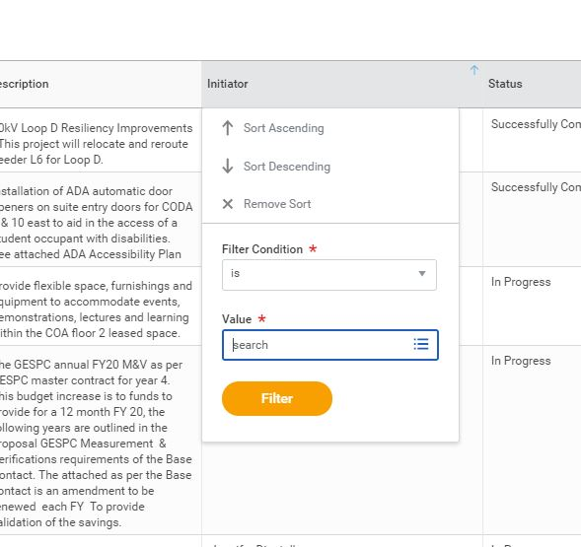

6. This report will eventually have the ‘ball in court’ information (or who’s queue the BA is in currently), but in the interim, this information is available in your Workday Inbox. Go to your inbox, open it, and click on Archive. Find the Budget Amendment. Note that the name listed is the person who currently has the BA in their in box for action or approval, and/or the BA will be noted as ‘Successfully Completed’ if the workflow is complete.
