Supplier Contract Event

VP Approval and Signature Step (Facilities)

FACILITIES SIGNATURE APPROVAL STEP

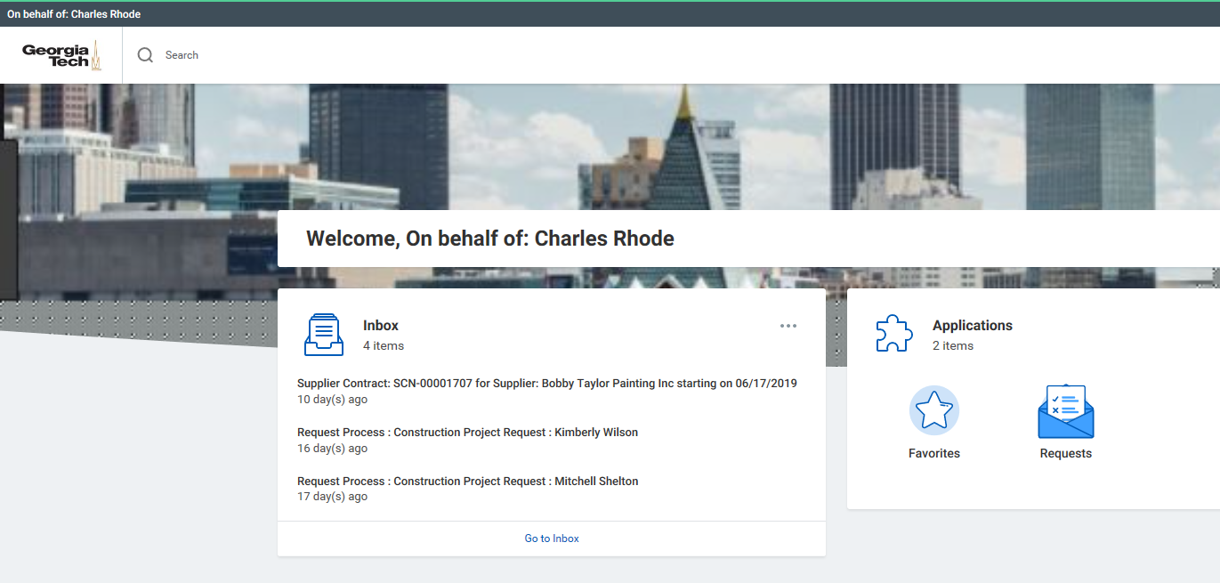

- Open Workday with the link provided or through Techworks. Contracts that are ready for review will be in your Workday inbox.
- Click on the Go to Inbox text to open inbox
- Inbox will open and show the first contract listed.
- You can change the contract being viewed by selecting the specific contract in your Inbox
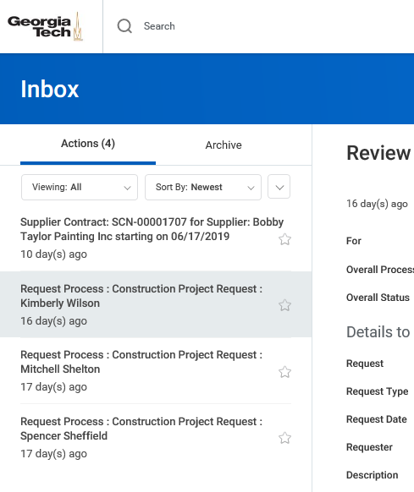

- Select and click on the contract that you would like to review first.
- Once you have selected the contract for review and approval
your screen will look like below:

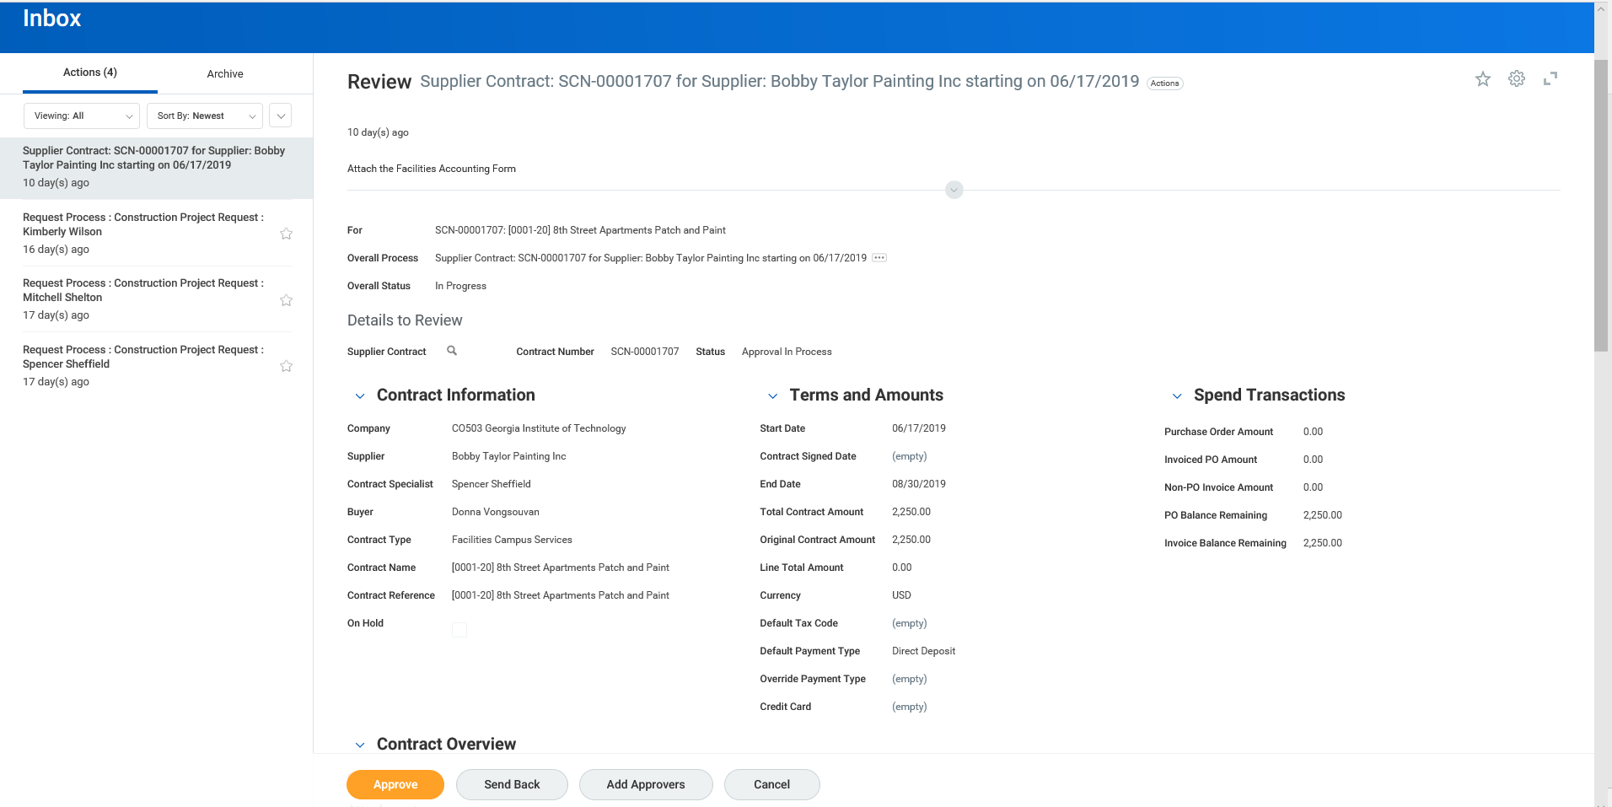

Tip: Scroll down using the right (grey) bar to advance to the rest of the form and details

The view shows the Contract Information such as the Supplier (Vendor/Contractor) Contract Specialist (Project Manager / Requestor), Buyer (Contracting Officer).

Under Terms and Amount you can review the contract start and completion dates as well as the amount of the contract.

Spend Transactions tracks the amount paid on the contract to date; for new contracts the first three lines will appear as 0.00

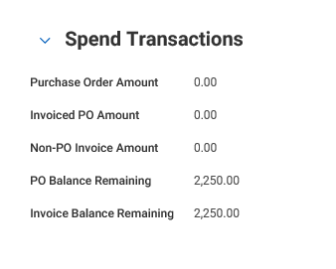

- Scroll down to the Contract Overview section

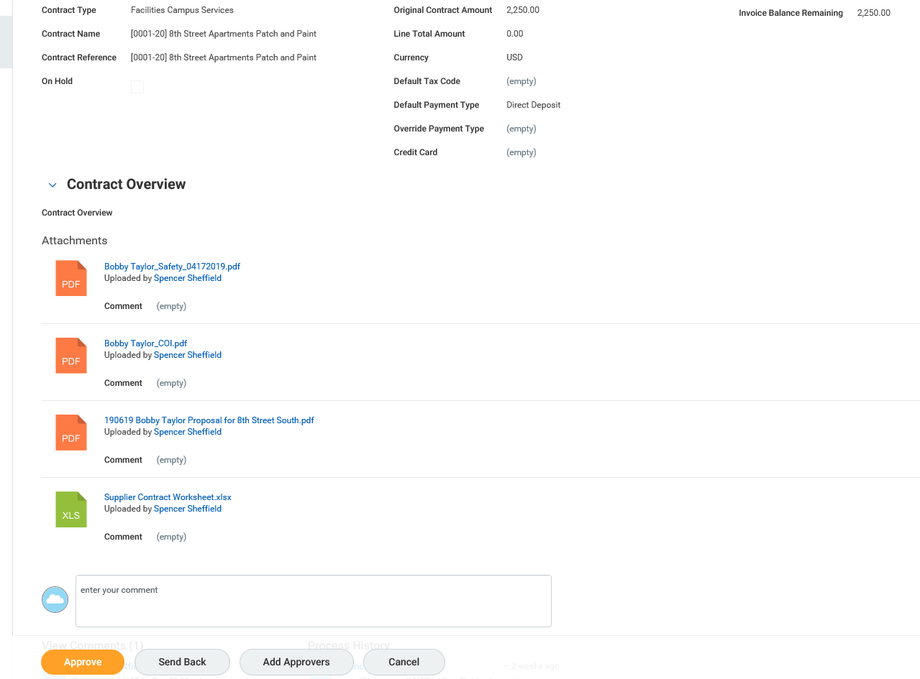

In the example above there are 3 PFD files and 1 Excel File attached.

- Select the blue text to open and view the attachment’s

- Review Attachments
  - To open attachments, click on the attachment link.
  - Use the arrows on the attachments to the right and left to navigate through the pages of the attachment.
  - Click on the arrow in the upper left-hand corner of the black bar to close out of the attachment.

Attachment example: Facilities Supplier Contract Worksheet (Excel Document)

Every new contract and addendum/change order will have a Facilities Supplier Contract Worksheet attached (Excel File) that provided the project and spend detail as provided by the Project Manager. See image of example below:

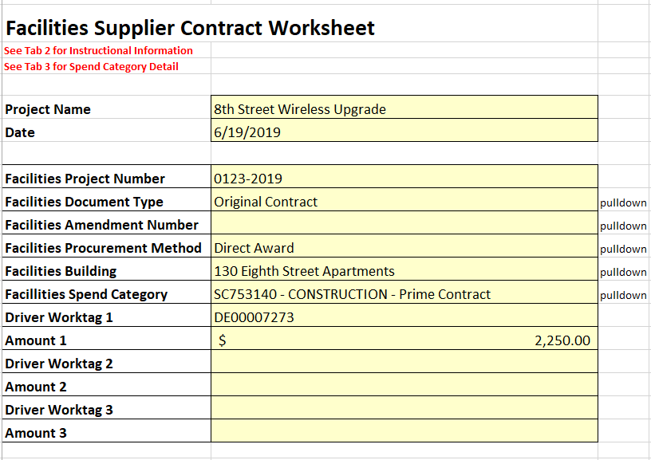

No action is required on your part other than reviewing the information.

As you further advance down below the attachment’s there is an area for additional comments. All notes are to be typed in in the cloud comment box.
DO NOT USE THE NOTE FUNCTION. PLACE COMMENTS IN THE BOX BELOW ONLY

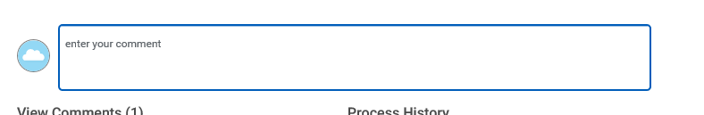

Below the Cloud Comment Box are the Comment and Process History Views where you can see additional information and review/approval stream in progress.
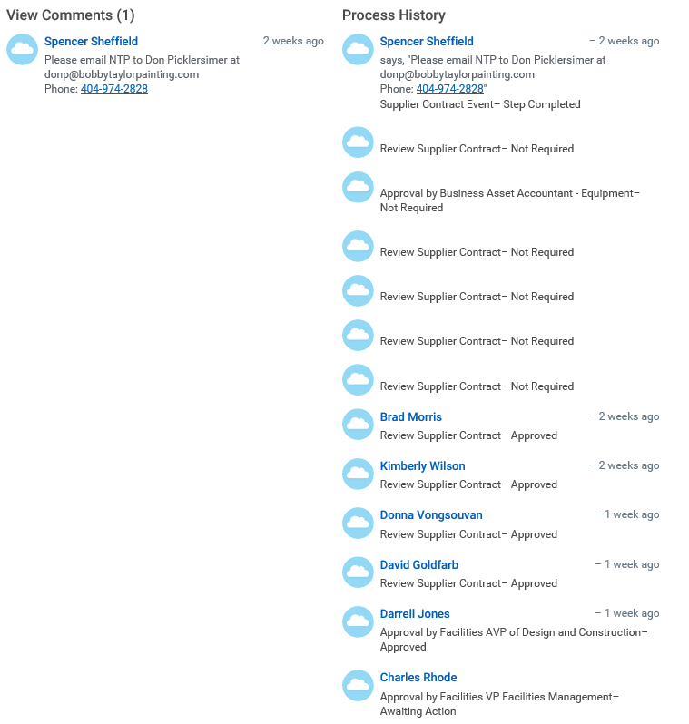
Contracts awaiting your approval will show a history of approval with Awaiting Action
under the next approvers name.
Below the View Comments and Process History, are the Approve, Send Back, Add Approvers and Cancel buttons.
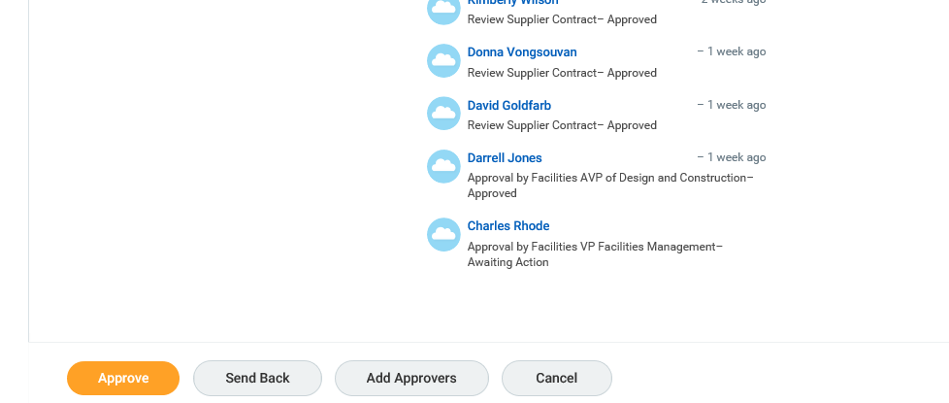

- Contract Review Action Options
  - Approve: to approve a contract, select the Approve button (Orange Button) at the bottom of the screen.
After approving go to DocuSign to e-sign the contract.

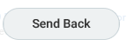
  - Send Back: to select the Send Back button at the bottom of the screen. A window box will pop up.
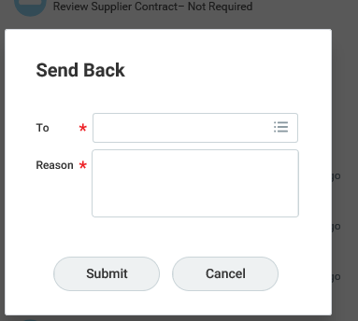

    - Select the 3 dots and lines to the right of the To line and click on the name of the person who initiated the contract, or another person in the review workflow to send the contract back.
    - Add notes in the Reason box associated with the Send Back button to explain why the contract has been returned. Remember that the only person in the workflow who can edit the contract data or attachments is the contract initiator.
    - Select Submit when complete or Cancel if you decide to not send back

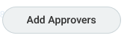
  - Add Approvers: to add an additional approver, select the Add Approvers if additional review outside of the workflow is required ad hoc.

    - Type the first name and first few letters of the person’s last name to search for the person to add. Select the person and add a note regarding
why they may need to review the contract. Select Submit to send or Cancel to delete step.

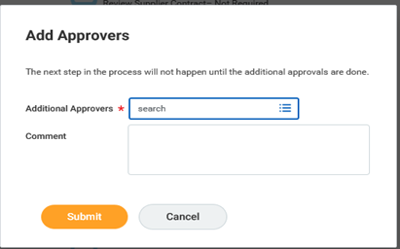
- Use DocuSign to securely electronically sign the contract that was just approve.
  - Open DocuSign (docusign.gatech.edu) and log in
  - Select document to sign from DocuSign inbox or from an email in Outlook by selecting REVIEW DOCUMENT
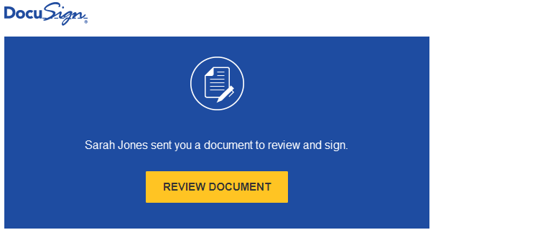
  - Accept the electronic signature agreement and click CONTINUE

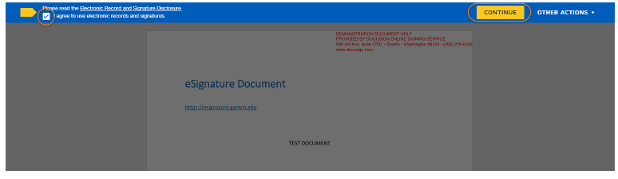
  - DocuSign will advance to the signature line where you will select SIGN and your approved uploaded electronic signature will be inserted and encrypted.
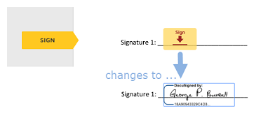

  - When all signature fields have been completed, select FINISH

The signed document will be sent to the originator (Contracting Officer for contracts) and uploaded by the Contracting Officer into Workday

