Project Manager Invoice Approval - Facilities

Overview
Approval of Invoices for Facilities Contracts.

Considerations
- Invoices enter Workday when vendors submit their invoices to gtfacinvoice@gatech.edu
- Because construction invoices require multiple signatures, best practice is for the GT project manager to review a draft invoice first. Once the invoice is finalized and approved by the GT project manager, the contractor should execute the invoice and procure the architect’s signature. At that point, the signed, finalized invoice can be submitted to the invoicing email gtfacinvoice@gatech.edu per instructions on the Notice to Proceed document issued with the executed contract agreement.
- Note that we are working to develop tabular queue reports to make many of these steps easier for project managers, particularly step 11, which involves looking up paid to date and invoice history information. Ultimately many of these steps and extra clicks to find information will be eliminated.

Initiation

- Log into Workday and go to your Workday Mailbox. Invoices that need approval will be visible in your inbox.

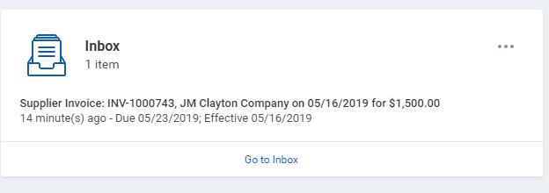

- Click on the invoice that you want to approve.
- A screen will appear with invoicing information
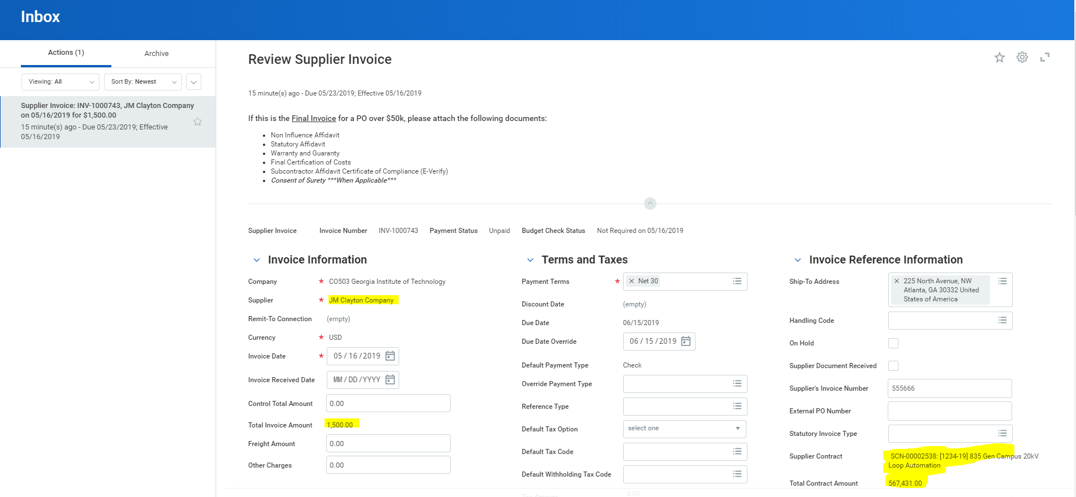
- Reviewing Basic Invoice Information:
  - Invoice Review:
    - A PDF of the invoice is located under attachments.
    - Double click on the blue hyperlink of the invoice to open and review.
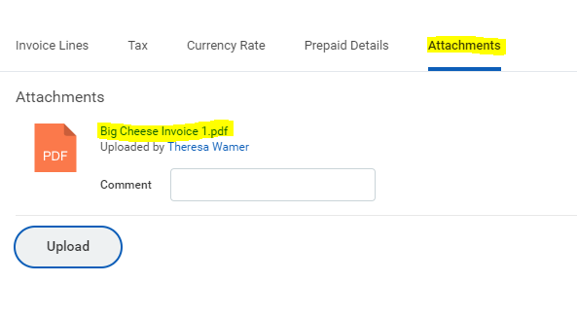

  - Review Workday fields against the invoice before approving:
    - Supplier
    - Invoice Amount
    - Supplier Contract + Facilities Contract Number
    - Total Contract Amount
    - Project + Facilities Project Number

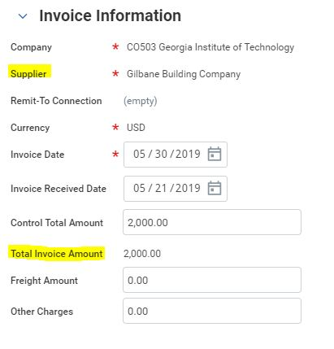
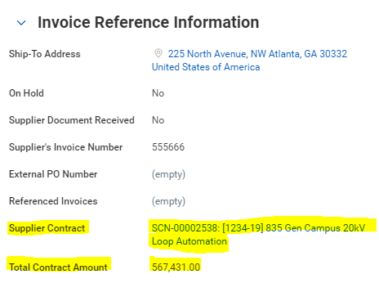
- If you scroll down the Facilities Project Number and Project Name are visible under the Invoice Lines tab. Scroll to the right to Project.
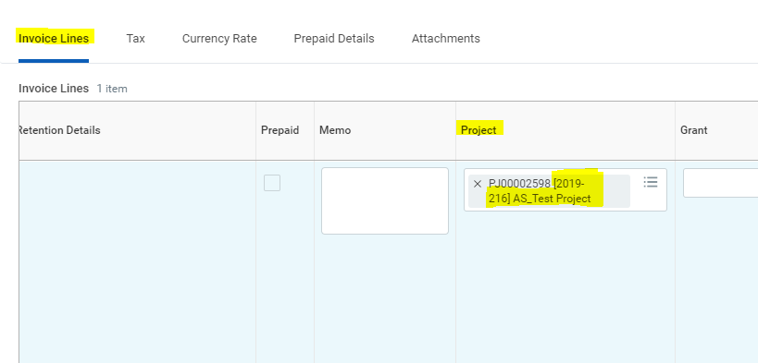

- Returned Invoices:
  - If there is an issue with the invoice and it is returned to your inbox, you will need to make corrections and route it back to accounting.
  - Open the invoice in your inbox. Notice that you can tell it’s a returned invoice by the description under the invoice. E.g. ‘Sent Back by Donna Vongsouvan’.
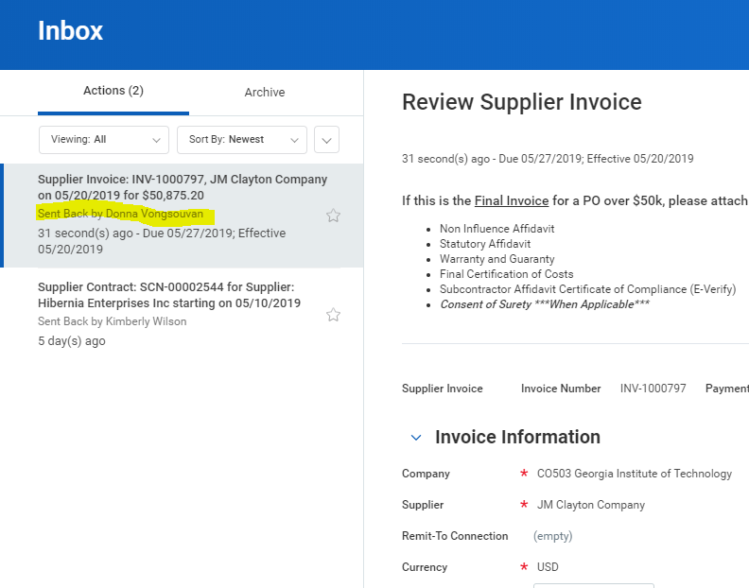
  - Make requested corrections and / or add requested documents. Be sure to respond to the comments in the CLOUD notes system.
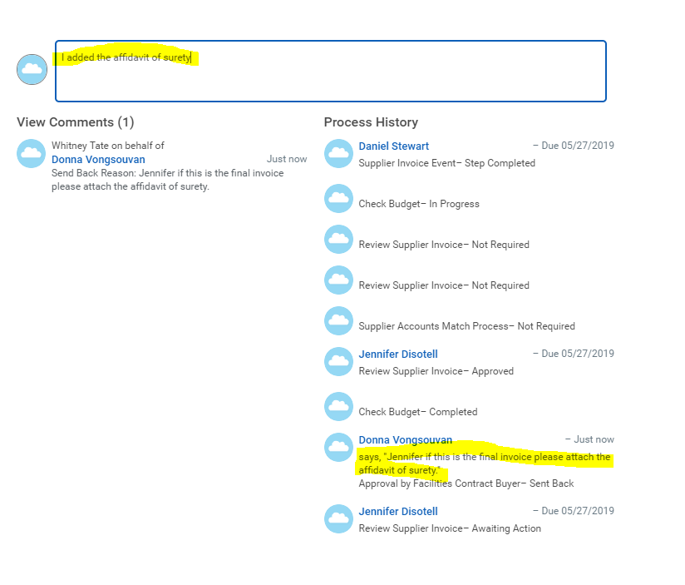
  - Click SEND BACK to return the invoice.

- Construction Invoices Requiring a GT PM Signature:
  - If the invoice is a construction invoice and the invoice form required by the contract requires a GT project manager signature, you can download the invoice, sign invoice, and then upload the signed invoice.
  - Right click on the invoice file name link to download.
  - Execute the invoice with your signature using Bluebeam or Adobe.
  - Upload the new PDF. Be sure to delete the original PDF of the invoice! Note that the PDF will not have a live link until after you submit the invoice for approval.
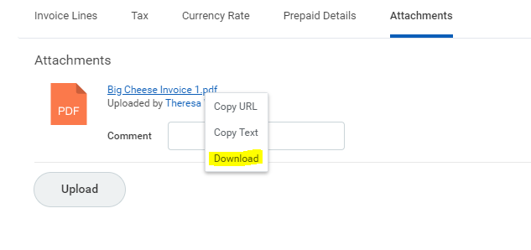
- Adding Documents during Review of an Invoice
  - Your invoice may be missing information, such as required financial close-out documents for contractors.
  - Go to the attachments tab of the invoice and upload any additional close-out documents.
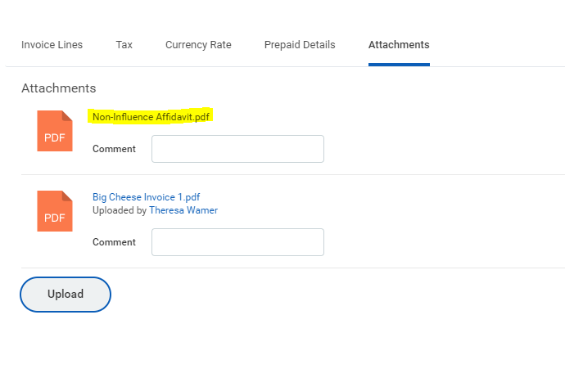

- Payment Funding Re-allocation: Some contracts are committed to multiple funding accounts, and invoice payment must be allocated to the funding accounts when paid. Allocation of invoice funding can be checked and adjusted as required. For example, you may have one funding source that needs to be paid down more quickly (e.g. state funds that can be lost).
  - The $value allocation of the invoice to various accounts (designated drivers) is visible under the Invoice Lines section of this screen. Scroll down to the Invoice Lines window tab and use the scroll bar at the bottom to find the Extended Amount and Designated Driver columns.
  - The Extended Amount is the dollar value of the invoice assigned to each funding account (Designated Drivers).
  - The Designated column shows the account information.
  - To change the allocation, simply adjust the values in the Extended Amount Column. Note that the values in the Extended Amount Column should sum to the invoice total after any adjustments are made.
  - Missing Account: If there is a funding account missing, utilize the cloud notes to communicate with accounting regarding the missing account and how you want the funding allocated. You should not attempt to ‘add a line’ in this situation. Let the accounting team do this for you and route the invoice back to you as needed.
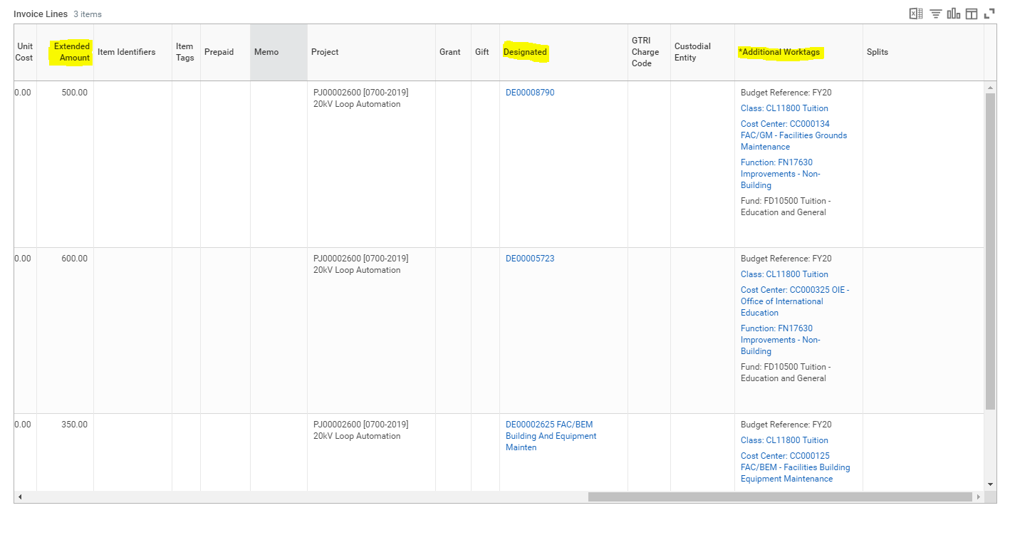
- Be sure to put a note in the Cloud notes system for the accounting team so that they are aware of the change, and there is a record of why the change has been made. 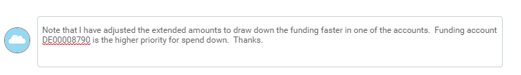
- Short Payment: You may need to short pay an invoice for several reasons: work is not complete, disputes, or to not fully pay out a contract so it will remain open because you are anticipating changes, etc.
  - The $value allocation of the invoice to various accounts (designated drivers) is visible under the Invoice Lines section of this screen. Scroll down to the Invoice Lines window tab and use the scroll bar at the bottom to find the Extended Amount and Designated Driver columns.
  - The Extended Amount is the dollar value of the invoice assigned to each funding account (Designated Drivers).
  - The Designated column shows the account information.
  - To change the allocation, simply adjust the values in the Extended Amount Column. For example, if you want to cut the pay, decrease the amount on one of the lines. The lines will sum to amount less than the invoice total.

  - Note that the Total Invoice Amount will automatically adjust down totaling up the adjusted lines.
  - Next you will need to change the Control Total Amount, reducing it to the total amount to be paid and aligning it with the Total Invoice Amount.
  - For example, if it is a $2,000 invoice, and you have cut $500 at the line level, the Total Invoice Amount will show a new total of $1,500 and you will need to adjust the Control Total Amount from $2,000 to $1,500.
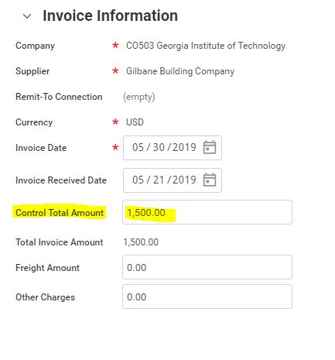

  - Ignore any alerts that you may receive regarding taxes.
  - Be sure to put a note in the Cloud notes system for the accounting team so that they are aware of the change, and there is a record of why the change has been made. Include the $value cut.
  - You should also let the vendor know that you have cut the invoice by email.
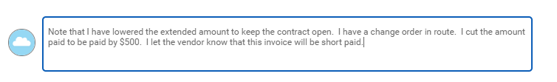
- Final Steps: At the bottom of the screen choose one of the following actions:

Approve:
You are approving the invoice and it will leave your queue.

Send Back:
Return the invoice back to the accounting department. Be sure to put a cloud note regarding
why you are returning the invoice.

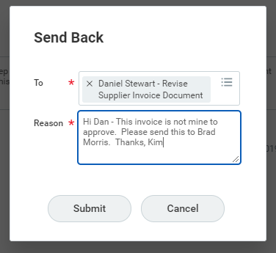

Save for Later:
Save any changes and the invoice will remain in your queue.

Cancel:
Do not save changes and the invoice will remain in your queue.

- DRILLING DOWN: Finding Invoice Paid to Date, Contract and Project Information
Note that we are working to develop tabular queue reports to make many of these steps easier for project managers, particularly this step.
  - In order to see the paid to date you will need to look up the contract.
  - Open a new tab in Workday by RIGHT clicking Actions to the right of the Invoice title and then click See in New Tab.
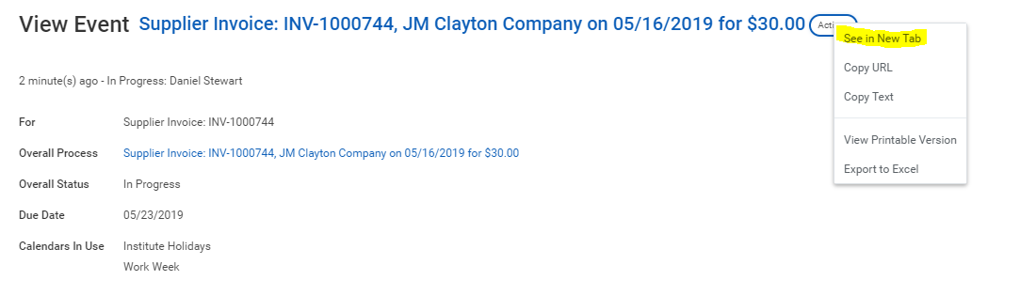
  - Under the Invoice Reference Information section, Click on the Supplier Contract link to open the contract.

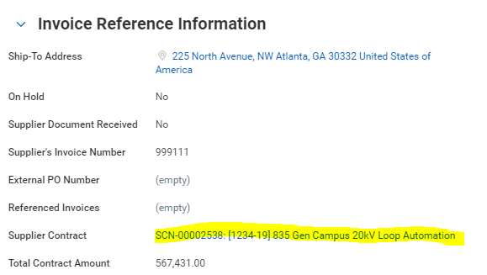
  - Look at the Spend Transactions section of the screen:
    - Invoiced PO Amount – This is the $value of invoices paid to date
    - Invoice Balance Remaining – This is the $value of funding not yet paid out.
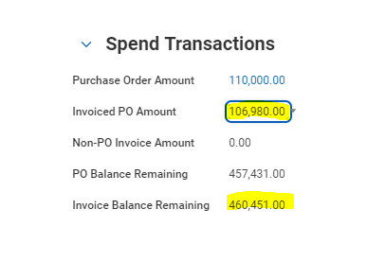
- Note that you can also see the invoice detail by clicking on the link under Invoiced PO Amount:
